NAME: ZOHAIB HASSAN
SESSION: 2022 - 2026 | COMPUTER SCIENCE
ROLL NUMBER: F22BDOCS1E02029

LungGuard AI
SOFTWARE REQUIREMENTS SPECIFICATION DOCUMENT
LungGuard AI
SOFTWARE REQUIREMENTS SPECIFICATION DOCUMENT
24.12.2025

Revision History
Date | Description | Author | Comments
24/12/2025 | Initial Draft Created | ZOHAIB HASSAN | First Version

Document Approval
The following Software Requirements Specification has been accepted and approved by the following:
Signature | Printed Name | Title | Date
 | Dr. Imran Sarwar Bajwa | Supervisor, CSIT 21306 | 24/12/2025

Contents
1 Introduction 5
1.1 Purpose 5
1.2 Scope 5
1.3 Definitions, Acronyms, and Abbreviations 6
1.4 Overview 6
2 The Overall Description 7
2.1 Product Perspective 7
2.2 Product Functions 7
2.3 User Characteristics 7
2.4 General Constraints 7
2.5 Assumptions and Dependencies 8
3 Specific Requirements 8
3.1 External Interface Requirements 8
3.1.1 System Interfaces 8
3.1.2 User Interfaces 8
3.1.3 Hardware Interfaces 8
3.1.4 Software Interfaces 8
3.2 Use Cases 8
3.3 Functional Requirements 8
3.3.1 FR-1: Radiologist Authentication System 8
3.3.2 FR-2: CT Scan Upload and Validation 8
3.3.3 FR-3: AI-Powered Cancer Detection 8
3.3.4 FR-4: Cancer Type Identification 8
3.3.5 FR-5: Instant Diagnosis Reporting 8
3.3.6 FR-6: Report History Management 8
3.4 Classes / Objects 8
3.4.1 Class: Radiologist 8
3.4.2 Class: CTScan 8
3.4.3 Class: Cancer Detection Model 8
3.4.4 Class: Diagnosis Report 8
3.5 Non-Functional Requirements 8
3.5.1 Performance 8
3.5.2 Reliability 8
3.5.3 Availability 8
3.5.4 Security 8
3.5.5 Maintainability 8
3.5.6 Portability 8
3.6 Inverse Requirements 8
3.7 Logical Database Requirements 8
3.8 Design Constraints 8
3.8.1 Standards Compliance 8
4 References 9

Introduction

Purpose
The purpose of LungGuard AI is to develop an advanced diagnostic support system that assists radiologists in the early detection and classification of lung cancer from CT scan images. It addresses the critical global challenge of lung cancer by leveraging artificial intelligence to provide rapid, automated analysis, identifying potential malignancies (Healthy, Benign, Malignant) and specific cancer types. The system aims to enhance diagnostic accuracy, reduce interpretation time, and support radiologists in making more confident and timely decisions, ultimately contributing to improved patient outcomes through earlier intervention. It is designed as a supportive tool that augments, rather than replaces, the expertise of the medical professional.

Scope
LungGuard AI is a web-based diagnostic support platform that enables radiologists to up- load lung CT scans, receive AI-powered cancer detection results, and maintain comprehensive patient records. The system encompasses secure radiologist authentication, CT scan upload and processing, AI-based cancer detection and classification, instant diagnosis with confidence scoring, and historical report management.
The system will provide:
- Secure radiologist login and session management
- CT scan image upload functionality
- AI-powered lung cancer detection (Healthy, Benign, Malignant)
- Cancer type identification and classification
- Instant diagnosis with confidence scores
- Comprehensive report history and patient record management
The system will NOT provide:
- Definitive medical diagnosis without radiologist validation
- Treatment recommendations or medical advice
- Integration with hospital EHR systems (in initial version)
- Web application interface
- Real-time imaging capabilities

Definitions, Acronyms, and Abbreviations
- CT: Computed Tomography
- AI: Artificial Intelligence
- CNN: Convolutional Neural Network
- IQ-OTH/NCCD: Iraqi Ministry of Health and Environment – National Center for Cancer Diseases
- EHR: Electronic Health Record
- SRS: Software Requirements Specification
- API: Application Programming Interface
- Benign: Non-cancerous tumor
- Malignant: Cancerous tumor capable of spreading

Overview
LungGuard AI is a secure, web-based diagnostic platform built on the Django framework. It integrates a specialized Convolutional Neural Network (CNN) trained on the IQ-OTH/NCCD lung cancer dataset. The system provides radiologists with an AI-powered tool to analyze CT scans for early signs of lung cancer. Its core function is to classify scans as Healthy, Benign, or Malignant and identify specific cancer types. Each analysis is delivered with a confidence score to aid radiologist interpretation. The platform features secure authentication, a streamlined interface for uploading scans, and instant generation of diagnostic reports. All reports and patient cases are maintained in a searchable history for tracking and review. Designed for clinical environments, it enhances diagnostic workflows while ensuring data security and upholding the radiologist's role in the final diagnosis.

The Overall Description

Product Perspective
LungGuard AI is a standalone web application designed to operate as a diagnostic support tool within clinical environments. The system integrates CNN-based AI models with a Django web framework to provide a seamless interface for radiologists. The product focuses on enhancing diagnostic accuracy and efficiency while maintaining compliance with medical software standards.

Product Functions
The core functionality of LungGuard AI includes:
- Secure Radiologist Authentication and session management
- CT Scan Upload and validation
- AI-powered Cancer Detection (Healthy/Benign/Malignant classification)
- Cancer Type Identification for malignant cases
- Confidence-based Diagnosis Reporting
- Comprehensive Report History management
- Patient record maintenance and tracking

User Characteristics
The primary user group consists of:
Radiologists: Medical professionals with specialized training in medical imaging interpretation. They require intuitive interfaces and reliable results to support their diagnostic workflow. All users are assumed to have medical expertise but varying levels of technical proficiency, necessitating a clean, intuitive interface design.

General Constraints
- Regulatory compliance with medical software standards
- Dependence on IQ-OTH/NCCD dataset for model training
- Hardware limitations for CT scan processing and storage
- Security requirements for patient data protection
- Integration capabilities for future EHR system connections

Assumptions and Dependencies
- The IQ-OTH/NCCD dataset provides sufficient quality and diversity for accurate model training
- Radiologists will upload CT scans in supported formats with appropriate quality
- The CNN model will maintain consistent performance across varied CT scan qualities
- Cloud deployment platforms will provide necessary computational resources

Specific Requirements

External Interface Requirements

System Interfaces
The system shall integrate with the hosting cloud platform and utilize Django’s built-in authentication and database management systems.

User Interfaces
The user interface shall include:
- Secure login/registration page for radiologists
- CT scan upload interface with drag-drop functionality
- Results display page with clear diagnosis and confidence scores
- Report history dashboard with search and filter capabilities

Hardware Interfaces
Standard web server infrastructure with sufficient storage for CT scan images and computational resources for AI model inference.

Software Interfaces
- Python 3.8+ with Django web framework
- TensorFlow/PyTorch for CNN model implementation
- Database system (SQLite/PostgreSQL)
- Modern web browsers (Chrome, Firefox, Safari, Edge)

    - Communications Interfaces
HTTP/HTTPS protocols for web communication, with secure API endpoints for future integrations.

Use Cases
    - Use Case 1: Perform Lung Cancer Diagnosis
Actor: Radiologist
Precondition: Radiologist is authenticated and has access to patient CT scans
Main Flow:
- Radiologist logs into the system
- Uploads patient CT scan images
- System processes images through AI models
- System displays detection results with confidence scores
- Radiologist reviews and validates results
- System saves report to history
Post condition: Diagnosis report generated and stored in system history
    - Use Case 2: Review Historical Reports
Actor: Radiologist
Precondition: Radiologist is authenticated and has previous reports
Main Flow:
- Radiologist accesses report history
- Applies filters and search criteria
- Reviews previous diagnosis reports
- Compares current and historical findings
Post condition: Radiologist gains comprehensive patient history overview
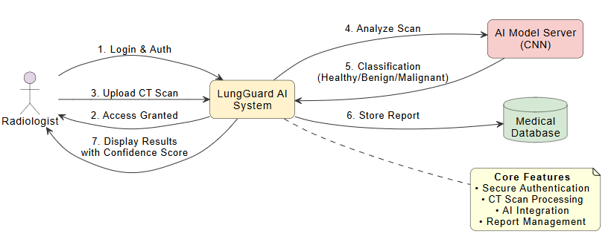
Figure 2: Data Flow Diagram

Functional Requirements

FR-1: Radiologist Authentication System
Introduction: The system shall provide secure authentication for radiologists to access the platform.
Inputs: Radiologist credentials (username/email and password)
Processing: Secure password hashing, session management, and access control
Outputs: Authenticated session, access to diagnostic features
Error Handling: Invalid credential handling, session timeout management

FR-2: CT Scan Upload and Validation
Introduction: The system shall allow authenticated radiologists to upload lung CT scan images.
Inputs: CT scan image files in supported formats (DICOM, JPEG, PNG)
Processing: File format validation, size verification, quality assessment
Outputs: Validated CT scans ready for AI processing
Error Handling: Invalid format rejection, size limitation enforcement

FR-3: AI-Powered Cancer Detection
Introduction: The system shall analyze CT scans using CNN models to detect cancer presence.
Inputs: Preprocessed CT scan images
Processing: CNN model inference for classification (Healthy/Benign/Malignant)
Outputs: Detection results with confidence scores
Error Handling: Model inference errors, confidence threshold validation

FR-4: Cancer Type Identification
Introduction: For malignant cases, the system shall identify specific cancer types.
Inputs: CT scans classified as malignant
Processing: Secondary CNN model analysis for type classification
Outputs: Cancer type identification with subtype specifications
Error Handling: Type classification confidence validation

FR-5: Instant Diagnosis Reporting
Introduction: The system shall generate comprehensive diagnosis reports.
Inputs: Detection results, confidence scores, cancer type information
Processing: Report generation with formatted results and recommendations
Outputs: Comprehensive diagnostic reports for radiologist review
Error Handling: Report generation failures, data consistency checks

FR-6: Report History Management
Introduction: The system shall maintain historical records of all diagnoses.
Inputs: Completed diagnostic reports, patient information
Processing: Database storage, retrieval, and management of historical data
Outputs: Searchable report history, patient case tracking
Error Handling: Data storage failures, retrieval errors

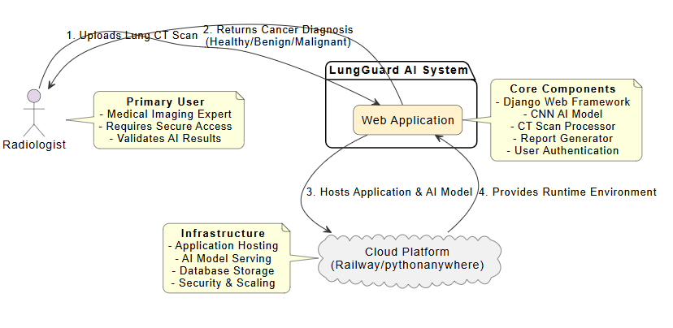

Figure 1: Detailed Architecture Diagram

Classes / Objects

Class: Radiologist
Attributes:
radiologistID, username, email, passwordHash, specialization, licenseNumber
Functions:
authenticate(), managePatients(), reviewHistory()

Class: CTScan
Attributes:
scanID, patientID, uploadDate, imageFile, scanQuality, preprocessingStatus

Functions:
validateScan(), preprocessImage(), storeScan()

Class: Cancer Detection Model
Attributes:
modelID, modelVersion, trainingData, accuracyMetrics, inputSpecs
Functions:
loadModel(), preprocessInput(), predict(), calculateConfidence()

Class: Diagnosis Report
Attributes:
reportID, scanID, radiologistID, detectionResult, confidenceScore, cancerType, reportDate
Functions:
generateReport(), saveReport(), retrieveReport()

Non-Functional Requirements

Performance
- CT scan processing and diagnosis within 15 seconds
- System response time under 3 seconds for all user interactions
- Support for multiple concurrent radiologist sessions

Reliability
- 99% system uptime during operational hours
- Consistent AI model performance across varied inputs
- Data integrity maintenance through automated backups

Availability
- 24/7 system accessibility with scheduled maintenance windows
- Graceful degradation during high load periods

Security
- Secure password hashing and storage
- HTTPS encryption for all data transmissions
- Regular security audits and vulnerability assessments
- Compliance with medical data protection standards

Maintainability
- Modular code structure for easy updates
- Comprehensive documentation and commenting
- Version control for all system components

Portability
- Cross-browser compatibility
- Cloud platform independence
- Easy deployment on standard web servers

Inverse Requirements
- The system shall not provide treatment recommendations
- The system shall not make final diagnostic decisions without radiologist oversight
- The system shall not store patient identifiable information without encryption
- The system shall not operate without radiologist authentication

Logical Database Requirements
The database design shall include:
- Radiologists table for user management
- Patients table for case management
- CTScans table for image storage metadata
- DiagnosisReports table for result tracking
- CancerTypes table for classification reference
- SessionLogs table for audit trails

Design Constraints

Standards Compliance
- Medical software regulatory standards
- Web accessibility guidelines (WCAG)
- Data protection and privacy regulations
- Django development best practices

References

IQ-OTH/NCCD Lung Cancer Dataset: https://www.kaggle.com/datasets/adityamahimkar/ iqothnccd-lung-cancer-dataset

Django Documentation: https://docs.djangoproject.com/

TensorFlow/PyTorch Documentation

World Health Organization - Cancer Fact Sheets

OWASP Web Security Guidelines

UML 2.5 Specification - Object Management Group (OMG), https://www.omg.org/spec/UML/

draw.io Diagrams (now diagrams.net) - Diagram creation tool used for UML diagrams, https://www.draw.io/

